## Scenario

Often in the industry we work on an existing code base not of our own design or making. To simulate this, we are going to exchange projects and modify the code, create new tests for functionality and integration of the new features, as well as regression test the system to ensure functionality.

## New Features

* Orders of 10 anvils or more qualify for 10% discount.
* Shipping is determined by the weight. An anvil weighs 50 pounds. Shipping is $5.00 per pound.
  + For addresses in California and Oregon, and for customers who order more than 5 anvils, shipping is discounted 10% from the new fees detailed below.
* Implement a Loyalty Club that receives a 15% discount on all purchases. Negative amounts on the invoice shall be enclosed in (). Client wants to include the amount of the discount on the invoice labelled "Loyalty Club Discount".
  + Determine eligibility for the Loyalty Club Loyalty discount.
    - Ask the customer whether they are a member of the Loyalty Club.
    - If they answer “Y” or “y”, give them a 15% pre-tax discount on the order.

*Amended Script Example:*

Are you a member of our Futility Club Loyalty program ("Y" if yes)? **y**

You'll get that AMAZING 15% loyalty bonus today!

*Amended Invoice Amount Section Example:*

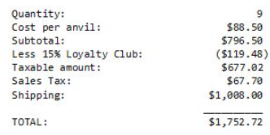

*IMPORTANT NOTE: If the customer is not a Loyalty Club member, do not show discount line on invoice.*

This illustration shows only the modified section. The rest of the invoice remains as specified in the original version.